|  |
| --- |
| **Community Pharmacies Online Ordering Platform** |

**AE1 Analysis and Design Assessment Report**

**Cover Page**

**Name**

**Student ID**

**Module Leader**

***Remember: Document Naming Convention***

***Upload Final Document/Code to Solent Online***

***Submission Deadline***

***Wednesday 28th January 2026, before 4:00 PM UK Time***

**The first assessment is purely an analysis and design assessment**

Table of Contents

Introduction 4

System Requirements 4

SDLC Process 5

• Planning 5

• Analysis 6

• Design 6

Planning and Analysis 7

Use-Case Texts 8

Thought Process 8

Tasks and System Interactions 8

List of Components 8

Reusability 8

Design and React Components 9

*Component 1* 9

UI Elements 9

Data Structure 9

Other Used Components 9

Hooks, Effects and Server Functions 9

Type (Client-Side or Server-Side) 9

Data Interactions 9

Conclusions and Reflections 9

Appendices 10

Table of Figures

Figure 1: Software Development Life Cycle (SDLC) 5

Figure 2: Use Case Diagram for the User Actor 8

Figure 3: Use Case Diagram of the Admin Actor 9

Introduction

Your task is to develop a web application using React that allows users to find the medications and health products they need from different pharmacies. The application should allow users to search for medicine category (categories like prescription medications, over-the-counter drugs, and wellness products) or by product name (such as Paracetamol), register, and manage their online orders. This application will serve as a shared pharmacies online ordering platform for different sets of products and medications. Admins should allow multiple community pharmacies to participate in this platform to offer their products to the customers.

The goal is to create an intuitive and interactive online platform that simplifies the process of managing the inventory of community pharmacies and offer online products to customers. A basic web app would likely need to handle user authentication, display pharmacy information, product information (product name, price, category, dosage, expiry date, and health information/usage/side effects ..etc), and potentially offer basic online ordering features. It would also need to have pharmacy administrator functionalities such as add/modifying pharmacy information (such as name, contact info and address/location) and manage products/medications offered by such pharmacy and manage customer orders. The app should be responsive and accessible on different devices.

System Requirements

The web application should have the following minimum requirements:

1. A user should be able to search for medicine/product category (categories like prescription medications, over-the-counter drugs, and wellness products) and other criteria such as pharmacy location.
2. A user should be able to order a product from a particular pharmacy and specify the quantity. Each product will have a specified quantity within the respective pharmacy stock that will be reduced when an order is made for that particular product, and users should be able to see the number of remaining quantity available of that particular product in that pharmacy records.
3. A user should be able to login with a username and password. Ideally, the system should be able to distinguish between regular users and administrators (Admins).
4. Admin users should have the ability to add new products to the inventory of a particular pharmacy within the platform, specifying details such as product name, price, category, dosage, expiry date in addition to the quantity available of that products in that pharmacy.
5. Admin users should be able to view a comprehensive list of all pharmacies, products and the number of available items and orders’ details. This should give Admins the ability to track medication/products stock in each pharmacy to avoid out-of-stock issues by monitoring inventory levels in real-time.
6. Users should be able to view their current and past orders in a list format. Selecting an item from this list should display the full details of that particular order, including items ordered, date, and amount paid.
7. Users should have the option to cancel their order before checking out, freeing up products and medications quantities ordered for other users.
8. Admin users should be able to edit and remove a drug/product from a particular pharmacy inventory within the system.
9. Participating pharmacies should be displayed on an interactive map based on their address or location. When a user clicks on a map marker for a particular pharmacy, a window should appear with details about that pharmacy including a list of available products and an option to order items directly from that list. This feature must utilize Leaflet and React, but you must not use google maps or any other third-party React mapping library.

SDLC Process



Figure 1: Software Development Life Cycle (SDLC)

* Planning
  + The planning phase typically includes tasks like cost-benefit analysis, scheduling, resource estimation, and allocation.
  + The development team collects requirements from several stakeholders such as customers, internal and external experts, and managers to create a software requirement specification (SRS) document.
  + The document sets expectations and defines common goals that aid in project planning.
  + The team estimates costs, creates a schedule, and has a detailed plan to achieve their goals.
* Analysis
  + This phase formally defines the detailed functional user requirements using high-level requirements identified in the Initiation and Feasibility Phases (Planning Phase).
  + The requirements are defined in this phase to a  level of detail sufficient for systems design to proceed.
  + They need to be measurable, testable, and relate to the business need or opportunity identified in the previous phase.
  + The purposes of this phase are to:
    - Complete business process reengineering of the functions to be supported, e.g., verify what information drives the business process, what information is generated, who generates it, where does the information go, and who processes it.
    - Develop detailed data and process models including system inputs and outputs.
    - Develop the test and evaluation requirements that will be used to determine acceptable system performance.
* Design
  + In the design phase, software engineers analyze requirements and identify the best solutions to create the software.
  + For example, they may consider integrating pre-existing modules, make technology choices, and identify development tools.
  + They will look at how to best integrate the new software into any existing IT infrastructure the organization may have.

**Planning/Analysis and Design Phases (Steps 1,2 and 3)**

You need to do the following:

**Planning and Analysis**

1. First, you must:
   1. Analyse the application scenario.

# **Example:**

# **Use Case List**

# **UC01 – Search for Product Name/Category**

# **UC02 – Search for Specific Pharmacy Location**

# **Use-Case Texts**

## **UC01 – Search for Product Category**

## **Primary Actor:** User (Customer)

## **Goal:** To find medicines or health products by browsing or searching product categories.

## **Preconditions:**

## User has access to the application.

## Categories exist in the system.

## **Trigger:** User enters a search query or selects a category.

## **Main Flow:**

## User enters a category in the search bar or selects one from a list.

## System retrieves categories matching the query.

## System displays the list of matching categories.

## User selects a category.

## System displays products within that category.

## **Postconditions:** Products in the selected category are displayed.

* 1. Draw up a list of use cases and a series of use-case texts, one for each use case.
  + You did use cases in OODD last year: the notes are still available at <https://nwcourses.github.io/COM528/> Or this specific link:
  + https://lilt.hikar.org/?topic=5&module=OODD

As an alternative (if you did not do OODD),

Analyse the scenario above and

1. list all the tasks that users of the system need to perform.
2. Break each task down into sub- steps which
   * describe what the user of the system needs to do, and
   * how the application will respond to the user for each step.

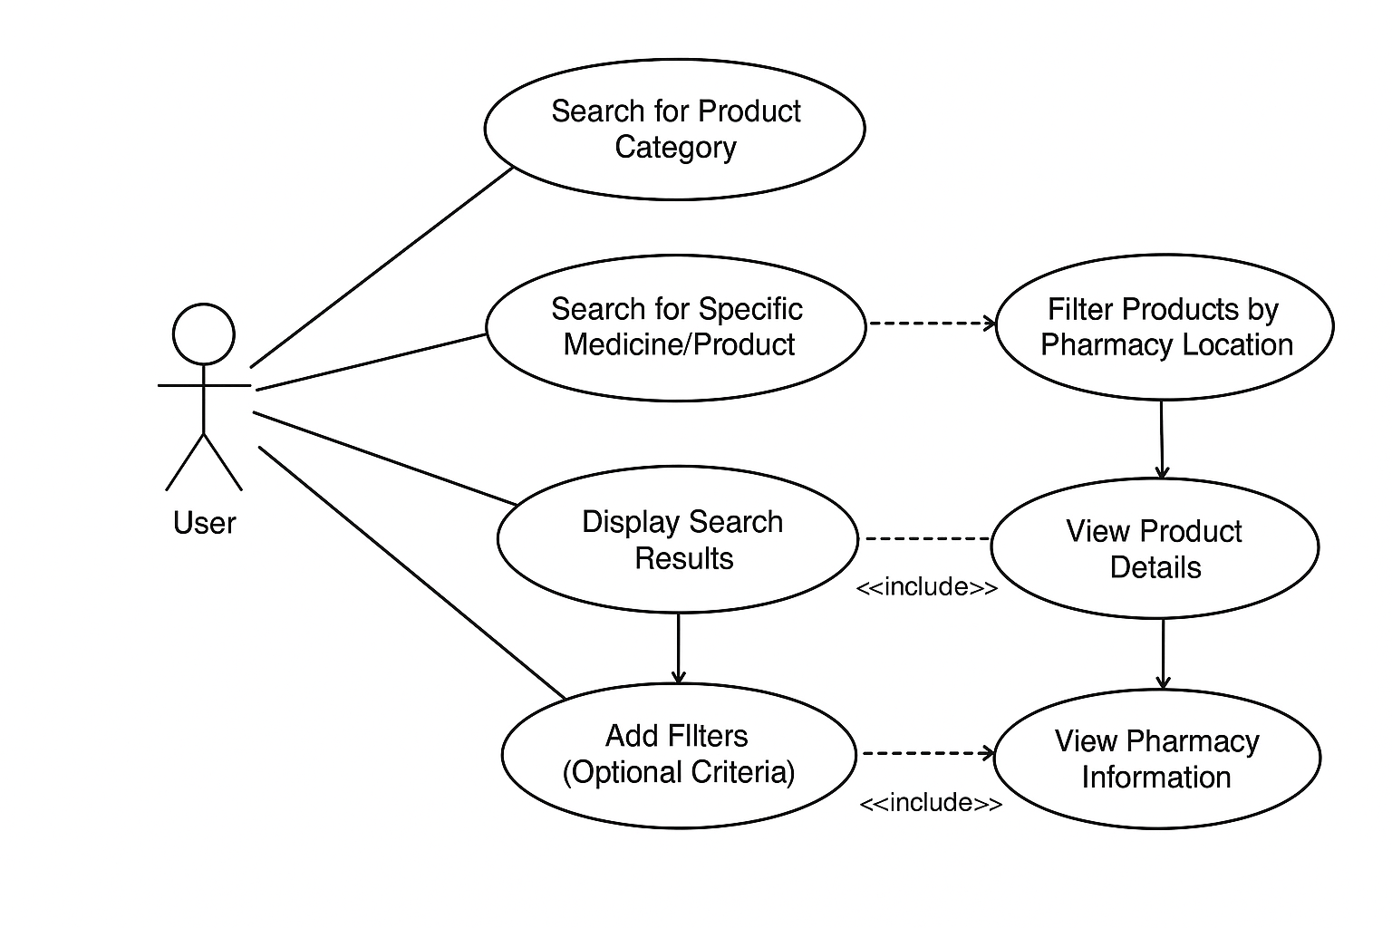

Figure : Use Case Diagram for the User Actor

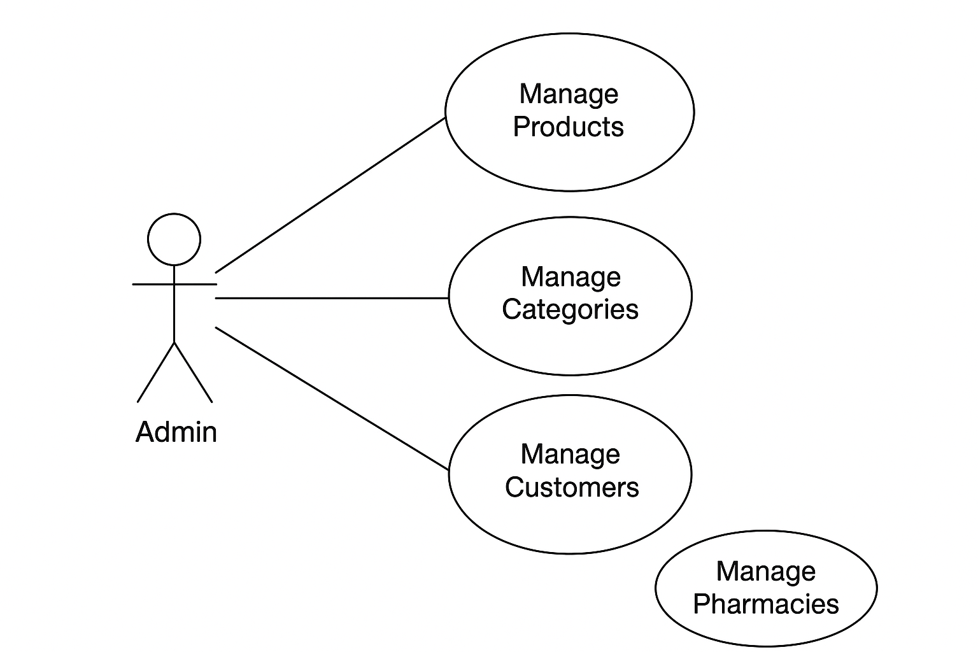

Figure : Use Case Diagram of the Admin Actor

1. By considering your use-case texts, you should then:
   1. list a series of React components which are required to implement the application.

**React Component List (Based on Use Cases)**

**1. Core Search Components**

**SearchBar**

* Allows user to type product name or category.
* Triggers search actions.

**CategorySelector**

* Displays categories (prescription, OTC, wellness).
* Lets user choose a category as a filter or main search input.

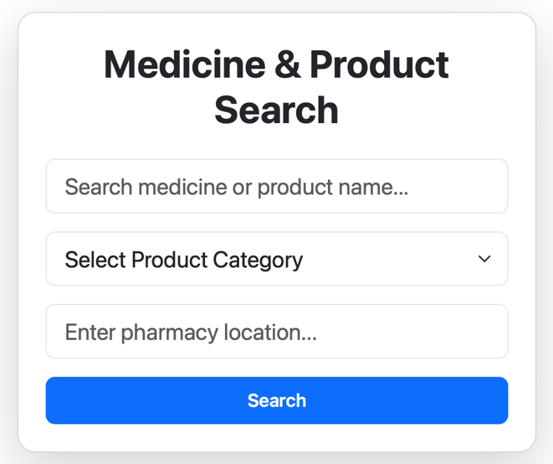

Figure : Search Panel (Product, Category and Location)

**2. Search Results & Display Components**

**🔹 SearchResultsList**

* Displays the list of products returned.
* Updates dynamically when filters change.

**🔹 ResultItem / ProductCard**

* Shows basic product info.
* Clickable to open product details.

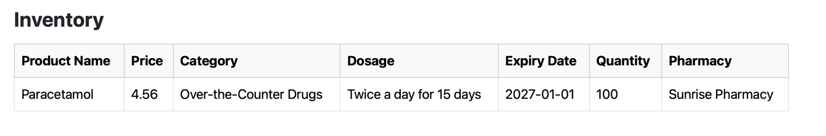

* 1. You must show your **thought processes** in **drawing up your list of React components**, by
     1. including a discussion explaining
        1. how you have used your use-case texts to decide on your list of components.
  2. Consider **reusability** when drawing up your list of components, and
  3. Explain how you have considered reusability in your accompanying discussion (Thought Process).

## Draw up a detailed design of each component. Again this must show your thought processes.

* 1. This should include the following:
  2. What UI elements might each component need?
  3. What data does each component need to store? Will this be stored in state?

# **Search Components**

## **SearchBar**

### **Data Needed;**

* searchQuery (text the user types)
* isTyping (optional)
* suggestions (autocomplete results)

### **Stored in State?**

Local state for searchQuery

1. What other components might the component need to contain?
2. What Hooks, Effects or Server Functions might it use?

# **Search Components**

## **SearchBar**

### **Hooks & Effects**

* useState → searchQuery,
* useEffect → Autocomplete requests

### **Server Functions**

* GET /api/categories?query=

1. Should the component be client-side or server-side, and why?

| **Component Type** | **Should Be** | **Reason** |
| --- | --- | --- |
| **Interactive UI elements** (inputs, filters, dropdowns, modals, sliders) | **Client-side** | They need state, event handlers, and reactivity. |
| **Pages that fetch data once and display it** | **Server-side** | Faster load, SEO-friendly, secure data fetching. |
| **Components that rely on browser-only APIs**(geolocation, maps) | **Client-side** | They can’t run on the server. |
| **Static layout components** | **Either**, but usually **server-side** | They don’t need interaction. |

**a. What interaction with a data source is necessary, and why?**

Your system is essentially a **product discovery and pharmacy location platform**.

Therefore, you need **consistent data access** to:

* Product information
* Pharmacy information
* Stock/availability
* User-driven search parameters
* Admin management data
* Geolocation-based filtering

1. **Product Search Flow**

## **SearchBar**

**Data Source Interaction:**

* None directly — but triggers queries.
* Sends search text to API → fetches product results.

**Why:**  
It must tell the backend what product name, location, or category the user is searching for.

## **CategorySelector**

**Data Source Interaction:**

* Fetch category list from server.

**Why:**  
Categories are dynamic (admins may add/remove them).

**UI Elements Needed for Each Component**

**1. Search Components**

**SearchBar**

* Text input field
* Search button (icon button or auto-search on typing)
* Clear input (×) icon
* Autocomplete dropdown (optional)
* Voice search icon (optional)

**CategorySelector**

* Drop-Down List of selectable category items
* [Optional] Icons for each category (e.g., pill, bandage, wellness leaf)
* Highlight/active state indicator

# *Conclusions and Reflections*

***Your report must show your thought processes while analysing the scenario and designing your application.***

***Tasks 2) and 3) must not merely read like a specification: they need to show your thought processes when performing the analysis and design.***

***If tasks 2) and 3) read merely like a specification, you risk a significant reduction in your grad***

# Appendices

(For extra explanations, diagrams, figures, tables and additional information)

**React Folder Structure**

src/

│

├── components/

│ ├── search/

│ │ ├── SearchBar.jsx

│ │ ├── CategorySelector.jsx

│ │ ├── LocationFilter.jsx

│ │ ├── FiltersPanel.jsx

│ │ └── FilterChip.jsx

│ │

│ ├── results/

│ │ ├── SearchResultsList.jsx

│ │ ├── ProductCard.jsx

│ │ └── Pagination.jsx

│ │

│ ├── product/

│ │ ├── ProductDetailsPage.jsx

│ │ ├── RelatedProducts.jsx

│ │ └── ProductInfo.jsx

│ │

│ ├── pharmacy/

│ │ ├── PharmacyList.jsx

│ │ ├── PharmacyCard.jsx

│ │ ├── PharmacyDetailsPage.jsx

│ │ └── MapView.jsx

│ │

│ ├── layout/

│ │ ├── Header.jsx

│ │ ├── Footer.jsx

│ │ └── Navigation.jsx

│ │

│ └── ui/

│ ├── LoadingSpinner.jsx

│ ├── ErrorMessage.jsx

│ └── Modal.jsx

│

├── pages/

│ ├── HomePage.jsx

│ ├── SearchPage.jsx

│ ├── ProductPage.jsx

│ └── PharmacyPage.jsx

│

├── hooks/

│ ├── useSearch.js

│ ├── useFilters.js

│ ├── useLocation.js

│ └── useFetch.js

│

├── context/

│ ├── SearchContext.jsx

│ ├── FiltersContext.jsx

│ └── LocationContext.jsx

│

├── services/

│ ├── api/

│ │ ├── productApi.js

│ │ ├── pharmacyApi.js

│ │ └── categoryApi.js

│ └── utils/

│ ├── formatters.js

│ └── validators.js

│

├── assets/

│ └── images/

│

├── styles/

│ └── global.css

│

└── App.jsx

User Login Component:

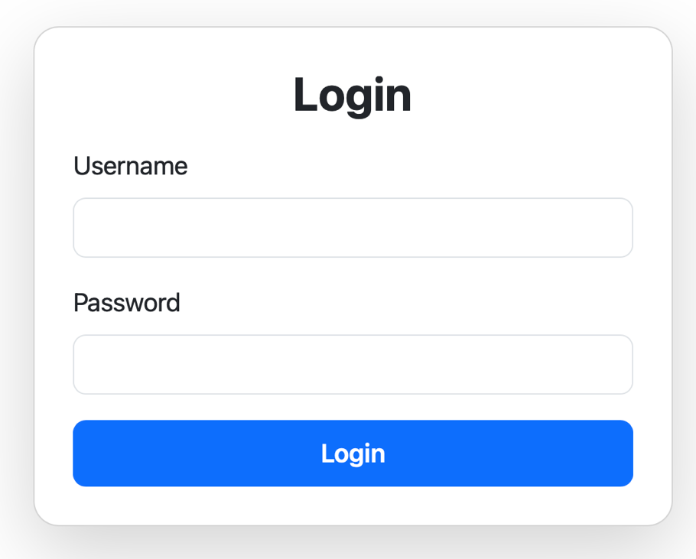

Admin Add Product Component

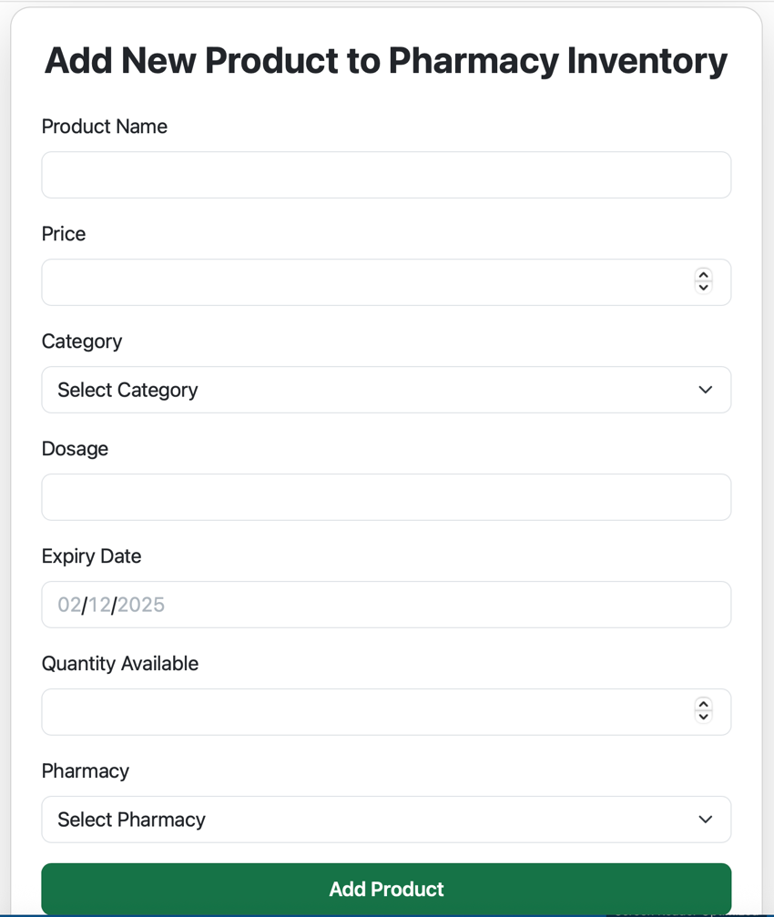

Product Order Component

